Health Campaign Integration Opportunities — Uganda
Planning period 2026–2028 | Prepared for the Campaign Integration Workshop, Kigali | June 2026

Abbreviations
Campaign acronyms used in this report and the workbook, with key technical terms.
Acronym | Definition | Acronym | Definition
MR | Measles–Rubella vaccine (SIA) | HPV | Human Papillomavirus vaccine
ITN/LLIN | Insecticide-Treated Net / Long-Lasting Insecticidal Net | IRS | Indoor Residual Spraying
SMC | Seasonal Malaria Chemoprevention | SCH | Schistosomiasis preventive chemotherapy
STH | Soil-Transmitted Helminthiases (deworming) | Oncho | Onchocerciasis (CDTI / mass drug administration)
Trachoma | Trachoma (mass drug administration) | VAS | Vitamin A Supplementation
CAST/ICHD | Community Awareness Testing and Screening / Integrated Child Health Days | ALB | Albendazole
AZI | Azithromycin | CDD | Community-Directed Distribution / Distributor
CDTI | Community-Directed Treatment with Ivermectin | ESPEN | Expanded Special Project for Elimination of NTDs
Gavi | Gavi, the Vaccine Alliance | IDA | Ivermectin + Diethylcarbamazine + Albendazole
IVM | Ivermectin | MDA | Mass Drug Administration
NTD | Neglected Tropical Disease | PC | Preventive Chemotherapy
PZQ | Praziquantel | SIA | Supplementary Immunization Activity
TEO | Tetracycline Eye Ointment | WHO | World Health Organization

Summary
Uganda's updated submission concentrates campaigns in 2026 and reports at national/aggregate level. In this version schistosomiasis and onchocerciasis have been re-timed into the recurring March / April / September / October windows, so the school-age and child-health interventions now cluster even more tightly; lymphatic filariasis is listed but carries no implementation month.
The calendar is therefore densely concentrated in four months — simultaneously a strong integration opportunity (a ready basis for integrated school and child-health days) and an operational-overload risk for the health workforce.

Integration opportunities (by time and place)
Window | Location | Interventions | Level | Recommended action
2026 · Mar/Apr/Sep/Oct | National | HPV + STH + SCH + Vitamin A | Co-delivery | Integrated school health days: HPV vaccination + deworming + praziquantel + VAS
2026 · Mar/Apr/Sep/Oct | Selected districts | Onchocerciasis + Trachoma | Co-delivery | Co-administer through the CDD network (ivermectin / azithromycin) — and schedule LF to join
2026 · Apr/May/Sep/Oct | Selected districts | SMC + Schistosomiasis | Collaboration | Shared community mobilisation and microplanning in the same windows
2026 · Oct | National | Measles-Rubella + child-health round | Co-delivery | Fold the October MR campaign into the integrated child-health day
Integration ladder: Coordination (shared planning calendar) → Collaboration (shared microplanning, mobilisation, transport, supervision) → Co-delivery (same teams/sites, same window) → Co-administration (products given together to the same person).

Profile-based complementarity
The school-age and child-health interventions — HPV, STH, schistosomiasis, Vitamin A and the CAST/ICHD platform — now share the same March, April, September and October windows at national level, making integrated school and child-health days the clear delivery vehicle (SCH + STH score 87; HPV + STH and MR + VAS 80). Onchocerciasis and trachoma have moved into the same windows in selected districts and can be co-administered through the community-directed distributor network.
Lymphatic filariasis is listed without an implementation month, so it no longer co-locates with onchocerciasis; scheduling it into the CDD round would restore that co-delivery. Because coverage is reported nationally rather than by admin-1, the overlaps are calendar-level; district microplanning is needed to confirm true co-location and to phase what is now a very dense four-month period.

Profile-based integration scan
How the score is generated. Every pair of campaigns is scored on two independent axes. Profile fit (0–100) measures operational similarity from the Campaign Characterisation sheet — a weighted match on delivery platform (×2), target population (×2), mode of delivery (×1) and commodity/supply class (×1). Time–place alignment (0–100) is read from the calendar: 100 = same admin-1 unit and same month in a year; 67 = same month, different place; 33 = same year only; 0 = no overlap. The combined integration score = 0.6 × profile fit + 0.4 × time–place, banded into Tier A (≥70), B (50–69), C (30–49) and D (<30).
How to read the figures. Table 2 (final landscape page) lists each campaign's characteristics — a shared cell colour down a column means a shared attribute, so rows sharing colours are integration candidates. The heatmap (Figure 1) gives the integration score for every pair (greener = higher potential). The 2×2 matrix (Figure 2) places each pair by profile fit (x) and time–place alignment (y): top-right = co-deliver now; bottom-right = operationally compatible, reschedule to align; top-left = coordinate logistics only (cannot co-administer); bottom-left = lower priority.

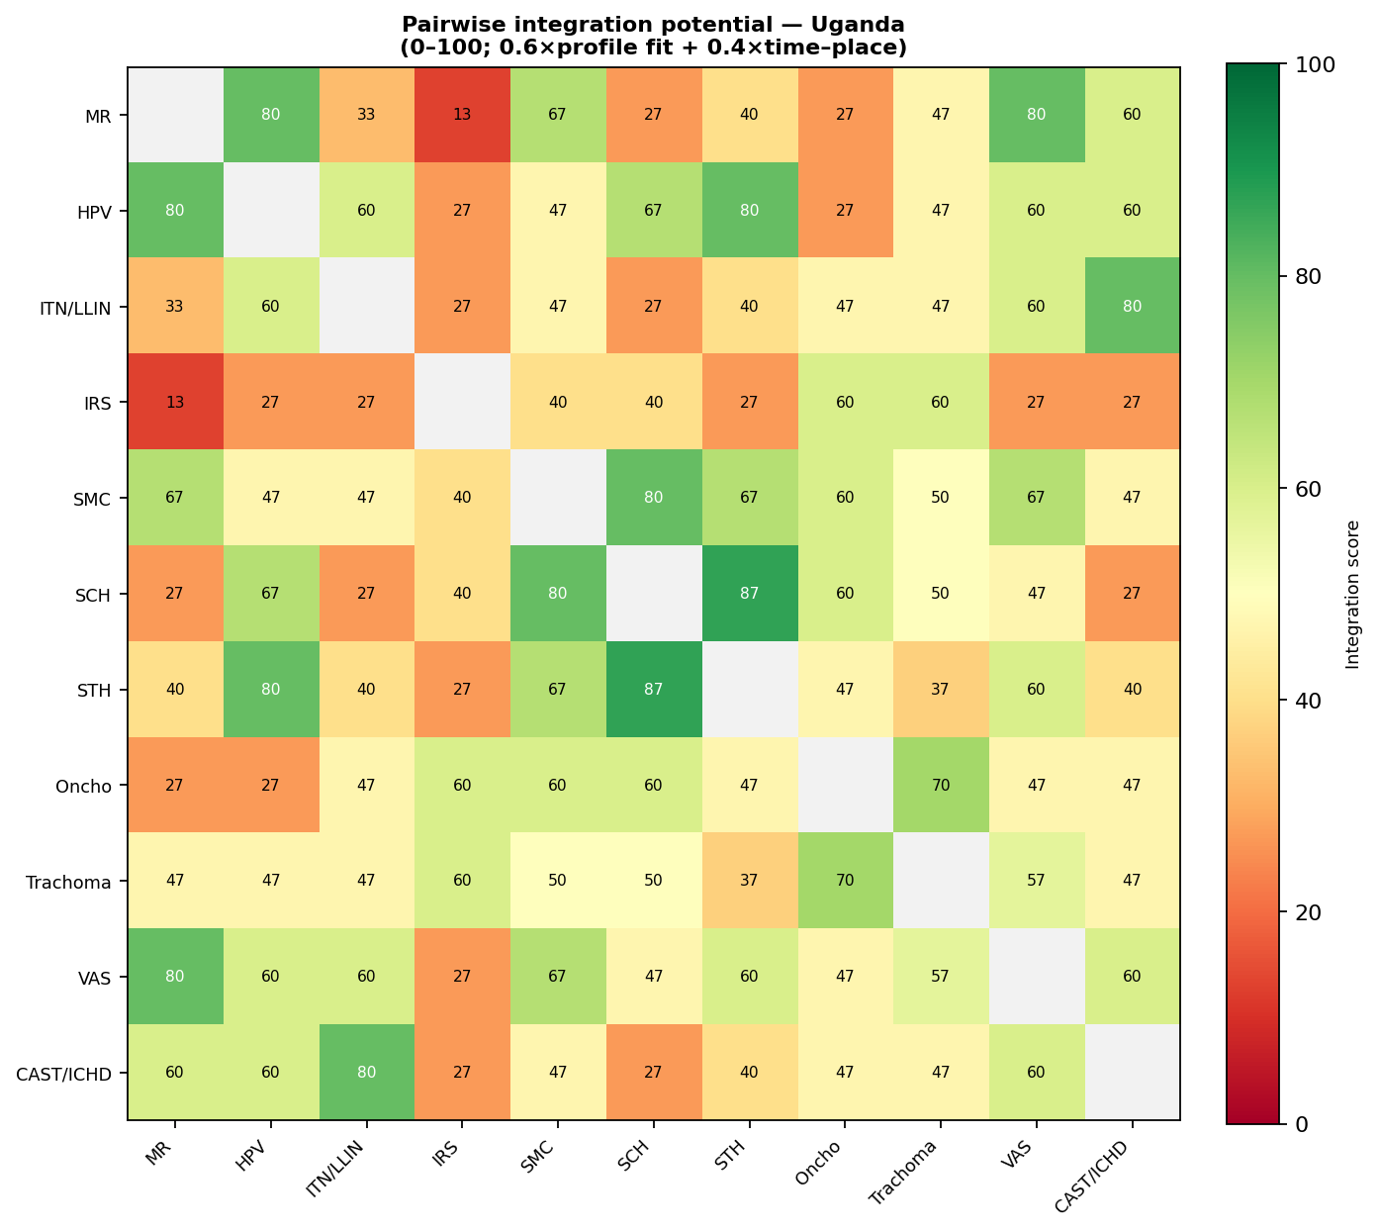
Figure 1. Pairwise integration potential (combined score 0–100).
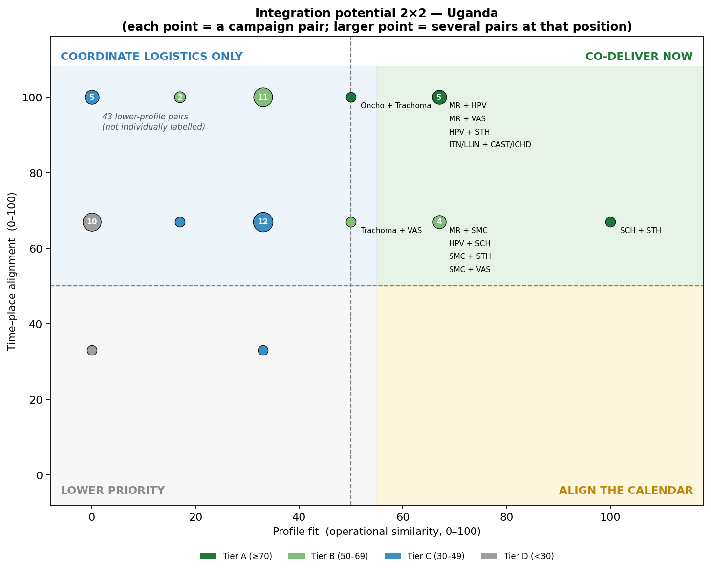
Figure 2. Integration potential 2×2 — each point is a campaign pair, triaged into an action quadrant.

Highest-scoring campaign pairs
Campaign pair | Score | Tier | Shared characteristics | Suggested action
SCH + STH | 87 | A | platform, target group, mode, supply | Co-deliver now
SMC + SCH | 80 | A | target group, mode, supply | Co-deliver now
MR + VAS | 80 | A | platform, target group | Co-deliver now
MR + HPV | 80 | A | platform, mode, supply | Co-deliver now
ITN/LLIN + CAST/ICHD | 80 | A | platform, target group | Co-deliver now
HPV + STH | 80 | A | platform, target group | Co-deliver now
Oncho + Trachoma | 70 | A | platform, supply | Co-deliver now
SMC + VAS | 67 | B | target group, mode, supply | Co-deliver now
SMC + STH | 67 | B | target group, mode, supply | Co-deliver now
MR + SMC | 67 | B | platform, target group | Co-deliver now

Recommendations
- Build integrated school & child-health days — co-deliver HPV, deworming, praziquantel and Vitamin A across the March/April/September/October windows.
- Co-administer the CDD NTDs — deliver onchocerciasis and trachoma together, and schedule LF (currently without dates) into the same CDD round.
- De-conflict the dense windows — use district microplans to phase the four concentrated months and protect coverage and workforce capacity.
- Improve geographic granularity — capture admin-1 (region) in the calendar so the integration scan reflects true co-location.

Annex — Table 2. Campaign characteristics by attribute
Shared colour within a column = shared attribute = co-delivery enabler. ‘+’ = campaign also uses other platforms / target groups.
